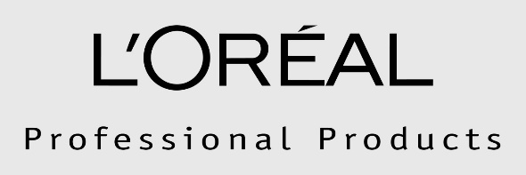
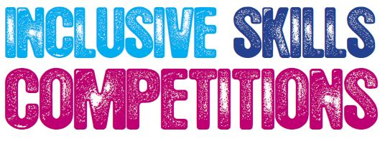

Competition Brief

Hairdressing
Date
Competitors will be invited to participate in a remote event, with photographic entries to be submitted by June 18th 2017.

Entry Requirements
This competition is for learners working at Entry Level 3.
Competitors must be 16 years of age or over.
A maximum of 3 competitors per organisation may enter.
Applications to be made via [regional lead email or portal address]. Deadline for entries: 7th April 2017

Competition Task
Test: Long Hair Fashion Style

Competitors will be required to dress long hair during the competition to create a total look that is then to be photographed and sent for remote judging.

Competitors have a free choice of Long Hair Design, which may consist of up-style, down-style or combination of both

NO colour is to be used for this skill test

Competitors will be required to carry out their look on mannequin head TH1137 available from Banbury Postiche. (www.banburypostiche.co.uk).

No dressing or draping of the mannequin is allowed.

No cutting of the mannequin is allowed.

Only when the style is complete and if required, competitors can use scissors to clean ends.

Judges will award points for:
- Hairstyle
- Ornamentation
- Styling & Finishing
- Continuity of Design

Hairstyle
- Shape
- Style
- Balance
- Creativity
- Reflecting current fashion trend

Finish
- Inspiration and creativity
- Cleanliness of finish
- Balance & Shape

Continuity of Design
- Overall design shows a continuity in all aspects and a degree of difficulty.
- Balance
- Total Look
- Continuity of all elements (textures / shape).

Marking and Assessment
Ladies Long Hair Fashion
Style / Design 40%
Finish 40%
Continuity of Design 20%
Total 100%

The tests will be assessed and marked in accordance with the general and specific competition rules.

The criteria for assessment are as set out on the attached forms. For all criteria and their
aspects the following marking scale will be used:

1 – Does not represent Industry Standard in any aspect

2 – Represents minimum Industry Standard in all aspects

3 – Mostly represents minimum Industry Standards, with a few areas of exceptional performance above Industry Standard

4 – Fully represents exceptional performance above Industry Standard in all aspects

Once marks have been agreed for each aspect of criterion, for each competitor, these will be converted to obtain an individual weighted score for each test.

A panel of judges have been drawn from industry, colleges and training providers. The judges’ decisions will be independently moderated and quality assured before being confirmed.

If a competitor has a complaint this be discussed with the Competition Organising Partner,
This will ensure that any problem is cleared up as soon as it occurs. If this is not possible the grievance procedure must be used, the procedure is found in the competitions rules, which is downloadable from http://www.worldskillsuk.org.

NB: The top candidates achieving the highest marks from all of the heats will be invited to the UK Final. Inclusive Skills will inform finalists and their tutors following moderation of marks from the passive competitions.

Additional information
1st Stage Photographic Entry – To be sent by June 18th 2017

You will be required to carry out your look on mannequin head TH1137 available from Banbury Postiche
Four Aspects are required - – front/ back/ left/ right
Photo Size - 8x10 ( 203cm x254cm )
Please note that photos should not be digitally edited or enhanced and should be the candidates own work

Photographs should be sent to:
FAO – Joanne Timms
C/O East Kent College
Dover Campus
Maison Dieu Road
Dover
CT16 1DH
M: 07551125225
E: joanne.timms@easkkent.ac.uk

Please ensure you attach a sticky label to the BACK of each photo covering the following:
Organisation name
Competitors name
Contact details

Please do not write on the photo
No photos will be returned
ALL Entries must be received at the above address by the closing date to be eligible for judging
ALL photographs received by the closing date WILL be judged

- Health and safety must be adhered to at all times throughout the competition
- No backcombing should be showing except the effect forms part of the finished look and this is clearly reflected
- No pins or bands showing
- The hair may be styled using a free choice of tools
- All styling products are allowed
- All styling tools are allowed
- All finishing techniques are accepted
- Finish should reflect the style created
- No added hair is allowed or ornamentation made from added hair
- No makeup may be added to the mannequins
- No jewellery may be added at any time
- No dressing or draping of the mannequin is allowed
- No cutting of the mannequin is allowed
- On completion of the style, only ends may be cleaned with scissors, if desired.
- Competitors will have 2 hours to complete their task.
- Verbal support can be given to competitors at the start of the task, but no physical help can be given.
- The judges’ decision is final.

If you require further information please contact:
For information specific to this regional competition, contact your regional competition lead:  [Regional competition lead name]  [Regional competition lead email address]  [Tel:] | For information about the content or technicalities of the competition, contact the national competition lead:  Joanne Timms  Joanne.timms@eastkent.ac.uk  Tel: 07551125225 | For general information about Inclusive Skills Competitions, contact the Projects & Partnerships Co-ordinator at Derwen College:  Helen Edwards  helen.edwards@derwen.ac.uk  Tel: 01691 661234 ext 354

